CaptionAI: AI-Powered Social Media Caption
Generator
Project Description:
The Credit Card Eligibility Prediction System is a web-based application that helps users quickly check whether they are likely to be eligible for a credit card. The user enters personal and financial details through a simple web interface. These details are processed by a trained Machine Learning model, which predicts whether the applicant is Accepted or Rejected based on the provided information. The prediction result is displayed directly on the same webpage within a few seconds, helping users understand their eligibility before applying for a credit card.

The application is built using HTML, CSS, and JavaScript for the frontend, Python and Flask for the backend, and Scikit-learn for implementing the Machine Learning model. Libraries such as Pandas, NumPy, and Joblib are used for data preprocessing, model loading, and prediction. The application is deployed on Render, making it accessible online through a web browser.

Scenarios

Scenario 1:
A user visits the website and enters valid personal and financial details such as age, annual income, credit score, employment history, and other required information. After clicking Predict Approval, the Machine Learning model analyzes the data and predicts that the applicant is Accepted. The result is displayed immediately on the website.

Scenario 2:
A user enters details with a low credit score, high debt-to-income ratio, or multiple prior defaults. After submitting the form, the Machine Learning model processes the information and predicts that the applicant is Rejected. The result is displayed on the same webpage within a few seconds.

Scenario 3:
A user submits the form without filling all the required fields or enters invalid values. The system validates the input and displays an appropriate error message, asking the user to correct the information before submitting again.

Technical Architecture:
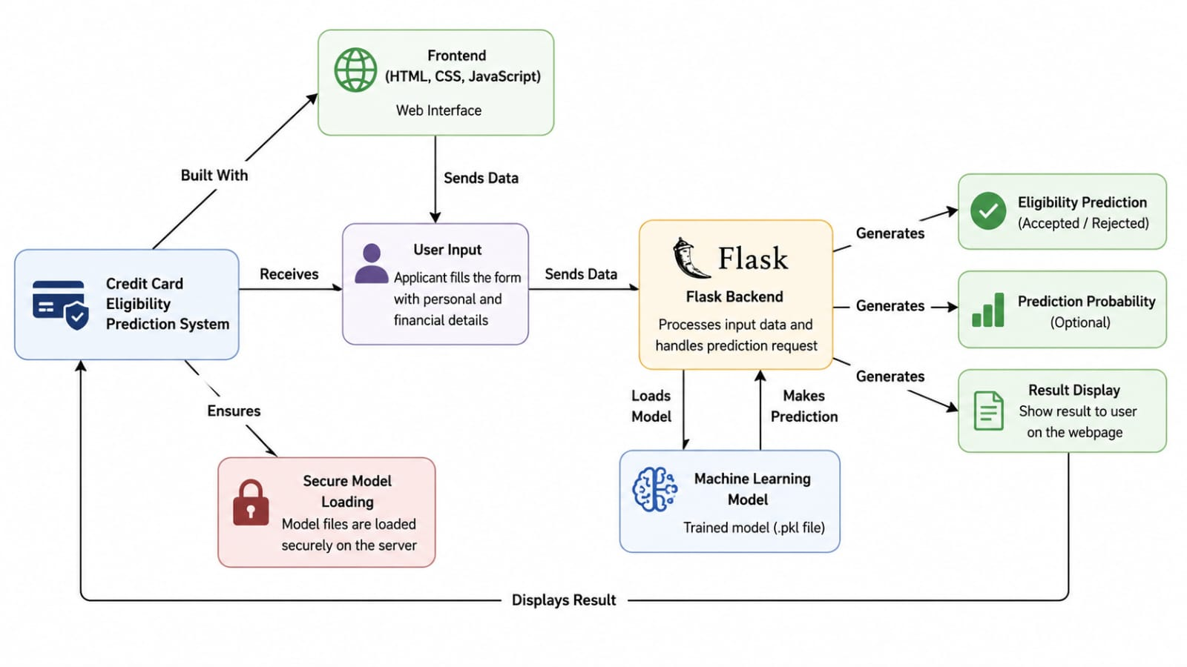

Pre-requisites:

• Python Programming Knowledge
• Flask Framework
• HTML, CSS, and JavaScript
• Machine Learning using Scikit-learn
• Pandas and NumPy
• MySQL Database
• Git & GitHub
• Render Deployment
• VS Code (Development Environment)

Project Workflow:

Milestone 1: Project Planning and Requirement Analysis

Activity 1.1 – Problem Identification

Activity 1.2 – Requirement Gathering

Activity 1.3 – Technology Selection

Activity 1.4 – Project Planning

Milestone 2: Machine Learning Model Development

Activity 2.1 – Data Collection

Activity 2.2 – Data Preprocessing

Activity 2.3 – Model Training

Activity 2.4 – Model Evaluation

Milestone 3: Web Application Development

Activity 3.1 – Frontend Development

Activity 3.2 – Backend Development

Activity 3.3 – Model Integration.

Activity 3.4 – Result Display

Milestone 4: Testing and Validation.

Activity 4.1 – Functional Testing

Activity 4.2 – Input Validation Testing

Activity 4.3 – Prediction Testing

Milestone 5: Deployment and Project Completion

Activity 5.1 – Application Deployment

Activity 5.2 – Documentation

Activity 5.3 – Final Demonstration

Activity 5.4 – Project Submission

Milestone 6: Conclusion
- Summarize the project, evaluate the system's performance, and discuss future enhancements such as improving prediction accuracy and adding new features.

Milestone 1: Project Planning and Requirement Analysis
Description:
This milestone focuses on understanding the problem faced by users who are unsure about their credit card eligibility. The team studies the project requirements, defines the project objectives, selects the technology stack, and prepares a plan for development. Roles and responsibilities are assigned to each team member to ensure smooth execution of the project.

Activity 1.1 – Problem Identification
The team identifies the challenges faced by users in determining their credit card eligibility and defines the problem statement.

Activity 1.2 – Requirement Gathering
The functional and non-functional requirements are collected and analyzed to understand the features needed in the application.

Activity 1.3 – Technology Selection
The team selects technologies such as HTML, CSS, JavaScript, Python, Flask, Scikit-learn, Pandas, NumPy, and Render for developing and deploying the application.

Activity 1.4 – Project Planning
A project schedule is prepared, milestones are defined, and tasks are distributed among team members.

Milestone 2: Machine Learning Model Development
Description:
This milestone focuses on building the Machine Learning model that predicts credit card eligibility. The dataset is prepared, cleaned, and processed before training different models. The best-performing model is selected and saved for integration with the web application.

Activity 2.1 – Data Collection
The credit card approval dataset is collected from a reliable source for training the model.

Activity 2.2 – Data Preprocessing
The dataset is cleaned by handling missing values, encoding categorical variables, and preparing it for model training.

Activity 2.3 – Model Training
Machine Learning algorithms are trained using the processed dataset to learn patterns related to credit card approval.

Activity 2.4 – Model Evaluation
The trained models are evaluated using performance metrics, and the best model is selected and saved using Joblib.

Milestone 3: Web Application Development
Description:
This milestone involves developing the web application that allows users to interact with the Machine Learning model. A simple and responsive user interface is created, and the backend is developed using Flask to process user requests and generate predictions.

Activity 3.1 – Frontend Development
The user interface is developed using HTML, CSS, and JavaScript to collect applicant information.

Activity 3.2 – Backend Development
The Flask backend is developed to receive user inputs, validate the data, and communicate with the Machine Learning model.

Activity 3.3 – Model Integration
The trained Machine Learning model is integrated with the Flask application to generate eligibility predictions.

Activity 3.4 – Result Display
The prediction result (Accepted or Rejected) is displayed on the same webpage within a few seconds.

Milestone 4: Testing and Validation
Description:
This milestone ensures that the application functions correctly under different conditions. Various tests are performed to verify the user interface, prediction accuracy, and system reliability before deployment.

Activity 4.1 – Functional Testing
The application is tested to verify that all features work according to the project requirements.

Activity 4.2 – Input Validation Testing
Different valid and invalid inputs are tested to ensure that appropriate validation messages are displayed.

Activity 4.3 – Prediction Testing
The Machine Learning model is tested with different applicant details to verify that predictions are generated correctly.

Activity 4.4 – Performance Testing
The application's response time and overall performance are evaluated to ensure smooth operation.

Milestone 5: Deployment and Project Completion
Description:
In the final milestone, the application is deployed on the Render platform and made accessible through a web browser. All project documents are prepared, and the completed system is demonstrated.

Activity 5.1 – Application Deployment
The Flask application is deployed on Render for online access.

Activity 5.2 – Documentation
Project reports, architecture diagrams, testing reports, and user manuals are prepared.

Activity 5.3 – Final Demonstration
The completed application is demonstrated by showing how users can enter their details and receive instant eligibility predictions.

Activity 5.4 – Project Submission
The final project, source code, documentation, and presentation are submitted for evaluation.
This format closely matches the style typically expected in project documentation, where each milestone has a descriptive paragraph followed by explanations of each activity rather than just listing the activities.

